**Name:** Pargat Singh

**Batch:** A2

**Roll No.:** 16010121045

**Date:** 12/01/2022

**CO 5:** Understand and apply basic concepts of spectroscopy and electro-analytical technique in characterizing chemical compounds.

**EXPERIMENT 10: Interpretation of IR spectra**

**FUNCTIONAL GROUPS AND IR TABLES:**

|  |  |  |  |
| --- | --- | --- | --- |
| **Characteristic IR Absorption Frequencies of Organic Functional Groups** | | | |
| **Functional Group** | **Type of Vibration** | **Characteristic Absorptions (cm-1)** | **Intensity** |
| **Alcohol** |  | | |
| O-H | (stretch, H-bonded) | 3200-3600 | strong, broad |
| O-H | (stretch, free) | 3500-3700 | strong, sharp |
| C-O | (stretch) | 1050-1150 | Strong |
| **Alkane** |  | | |
| C-H | stretch | 2850-3000 | Strong |
| -C-H | bending | 1350-1480 | Variable |
| **Alkene** |  | | |
| =C-H | stretch | 3010-3100 | Medium |
| =C-H | bending | 675-1000 | Strong |
| C=C | stretch | 1620-1680 | Variable |
| **Alkyl Halide** |  | | |
| C-F | stretch | 1000-1400 | Strong |
| C-Cl | stretch | 600-800 | Strong |
| C-Br | stretch | 500-600 | Strong |
| C-I | stretch | 500 | Strong |
| **Alkyne** |  | | |
| C-H | stretch | 3300 | strong,sharp |
| http://www2.ups.edu/faculty/hanson/Spectroscopy/IR/IRalkyne.gif | stretch | 2100-2260 | variable, not present in symmetrical alkynes |
| **Amine** |  | | |
| N-H | stretch | 3300-3500 | medium (primary amines have two bands; secondary have one band, often very weak) |
| C-N | stretch | 1080-1360 | medium-weak |
| N-H | bending | 1600 | Medium |
| **Aromatic** |  | | |
| C-H | stretch | 3000-3100 | Medium |
| C=C | stretch | 1400-1600 | medium-weak, multiple bands |
| Analysis of C-H out-of-plane bending can often distinguish substitution patterns | | | |
| **Carbonyl** | [Detailed Information on Carbonyl IR](http://www2.ups.edu/faculty/hanson/Spectroscopy/IR/IRfrequencies.html#carbonylIR) | | |
| C=O | stretch | 1670-1820 | Strong |
| (conjugation moves absorptions to lower wave numbers) | | | |
| **Ether** |  | | |
| C-O | stretch | 1000-1300 (1070-1150) | Strong |
| **Nitrile** |  | | |
| CN | stretch | 2210-2260 | Medium |
| **Nitro** |  | | |
| N-O | stretch | 1515-1560 & 1345-1385 | strong, two bands |

|  |  |  |  |
| --- | --- | --- | --- |
| **IR Absorption Frequencies of Functional Groups Containing a Carbonyl (C=O)** | | | |
| **Functional Group** | **Type of Vibration** | **Characteristic Absorptions (cm-1)** | **Intensity** |
| **Carbonyl** |  | | |
| C=O | stretch | 1670-1820 | Strong |
| (conjugation moves absorptions to lower wave numbers) | | | |
| **Acid** |  | | |
| C=O | stretch | 1700-1725 | Strong |
| O-H | stretch | 2500-3300 | strong, very broad |
| C-O | stretch | 1210-1320 | Strong |
| **Aldehyde** |  | | |
| C=O | stretch | 1740-1720 | Strong |
| =C-H | stretch | 2820-2850 & 2720-2750 | medium, two peaks |
| **Amide** |  | | |
| C=O | stretch | 1640-1690 | Strong |
| N-H | stretch | 3100-3500 | unsubstituted have two bands |
| N-H | bending | 1550-1640 |  |
| **Anhydride** |  | | |
| C=O | stretch | 1800-1830 & 1740-1775 | two bands |
| **Ester** |  | | |
| C=O | stretch | 1735-1750 | Strong |
| C-O | stretch | 1000-1300 | two bands or more |
| **Ketone** |  | | |
| acyclic | stretch | 1705-1725 | Strong |
| cyclic | stretch | 3-membered - 1850 4-membered - 1780 5-membered - 1745 6-membered - 1715 7-membered - 1705 | Strong |
| ,-unsaturated | stretch | 1665-1685 | Strong |
| aryl ketone | stretch | 1680-1700 | Strong |

1.

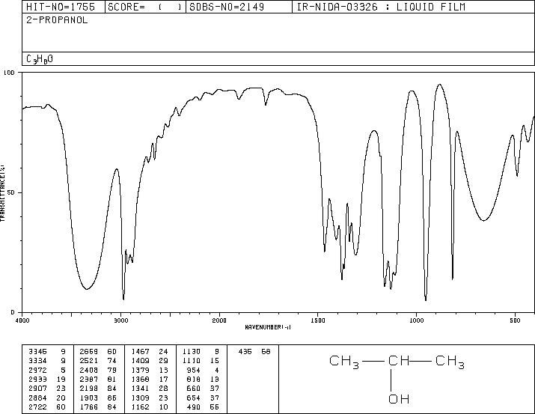

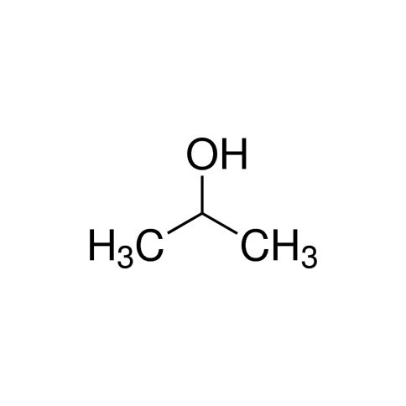

|  |  |  |  |  |
| --- | --- | --- | --- | --- |
| Sr.No | Observation  Frequency | Frequency  Range | Type of  Vibration | Intensity |
| 1. | 3345,3334 | 3200-3600 | O-H | Strong, broad |
| 2. | 2972,2845 | 2850-3000 | C-H | Strong |
| 3. | 1740,1720 | 1740-1720 | C=O | Strong |
| 4. | 1130,1110 | 1070-1150 | C-O | Strong |

ISOPROPYL ALCOHOL

The number of atoms in C3H8O = 12

The molecule is ionic.

Thus, total number of vibrational moles = 3N-5

= 3(12)-5 =31

2.

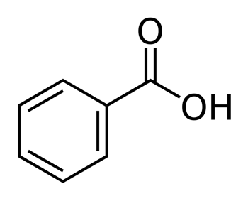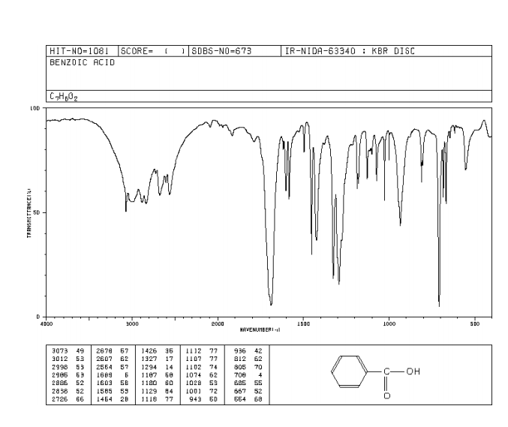



|  |  |  |  |  |
| --- | --- | --- | --- | --- |
| Sr.No | Observation  Frequency | Frequency  Range | Type of  Vibration | Intensity |
| 1. | 3500,2500 | 2200-3600 | O-H(stretch) | Strong, sharp |
| 2. | 2800,2500 | 2500-3300 | C-H | Strong, very broad |
| 3. | 1685,1792 | 1670-1820 | C=O | Strong |
| 4. | 934 | - | C-H | Medium |

BENZOIC ACID

The number of atoms in C7H6O2 = 15

The molecule is non polar.

Thus, total number of vibrational moles = 3N-5

= 3(15)-5 =40

3.

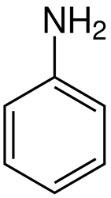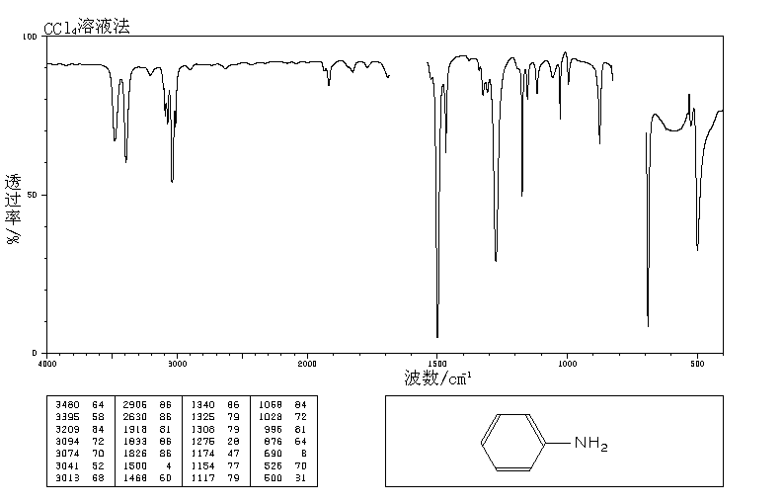

C6H7N

|  |  |  |  |  |
| --- | --- | --- | --- | --- |
| Sr.No | Observation  Frequency | Frequency  Range | Type of  Vibration | Intensity |
| 1 | 3442,3360 | 3300-3500 | N-H(primary) | Medium |
| 2 | 1281 | 1080-1360 | C-N(stretch) | Medium weak |
| 3 | 1619 | 1600 | N-H(Bend) | Medium |

ANILINE

The number of atoms in C6H7N = 14

The molecule is polar.

Thus, total number of vibrational moles = 3N-5

= 3(14)-5 =37

4.

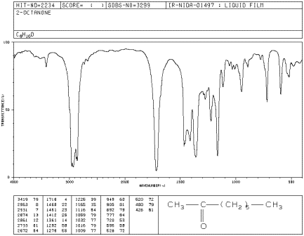

 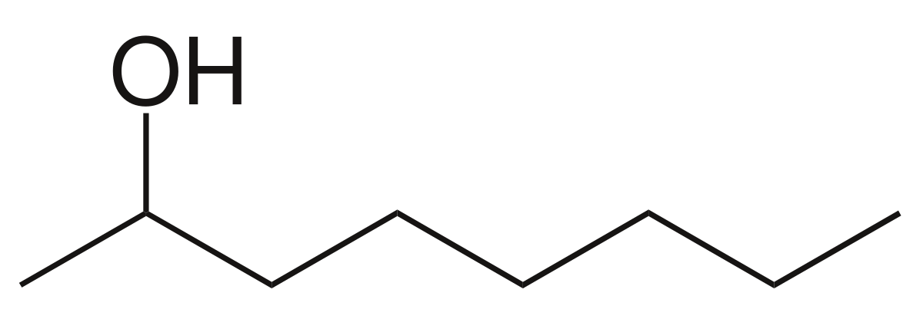

|  |  |  |  |  |
| --- | --- | --- | --- | --- |
| Sr.No | Observation  Frequency | Frequency  Range | Type of  Vibration | Intensity |
| 1. | 3230,3500 | 3300 (Sharp) | O-H | Strong, broad. |
| 2. | 2950,2850 | 2850-3000 | C-H | Strong |
| 3. | 1075,1050 | 1050-1150 | C-O & C-H | Strong(stretch) |
| 4. | 500,700 | 675-1000 | =C-H | Strong |

OCTANOL

The number of atoms in C8H16O = 23

The molecule is polar.

Thus, total number of vibrational moles = 3N-5

= 3(23)-5 = 64

5.

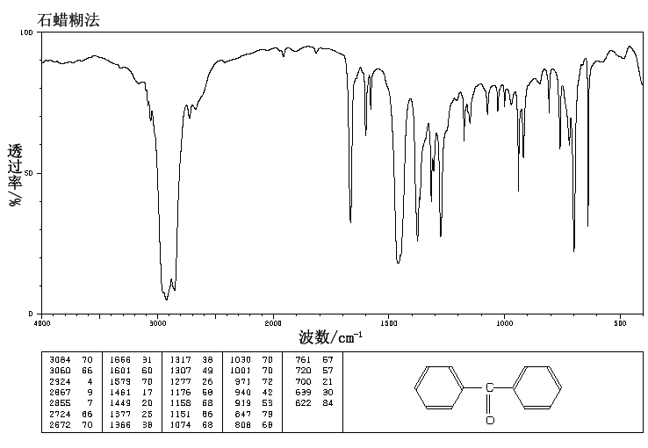

 C13H10O 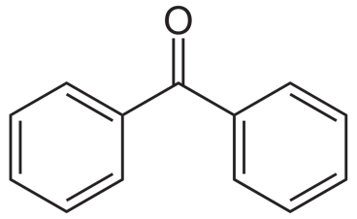

|  |  |  |  |  |
| --- | --- | --- | --- | --- |
| Sr.No | Observation  Frequency | Frequency  Range | Type of  Vibration | Intensity |
| 1. | 1656,1601 | 1705-1725 | C=O | Strong |
| 2. | 1669,1461,1579 | 1400-1600 | C=C | Variable |
| 3. | 3060,3084 | 3000-3100 | C=C | Variable |
| 4. | 2724,2855 | 2820-2860 & 2720-2750 | =C-H | Medium, two peaks |

BENZOPHENONE

The number of atoms in C13H10O = 24

The molecule is non polar.

Thus, total number of vibrational moles = 3N-5 = 3(24)-5 = 67